Project: Radar with ultrasonic sensor
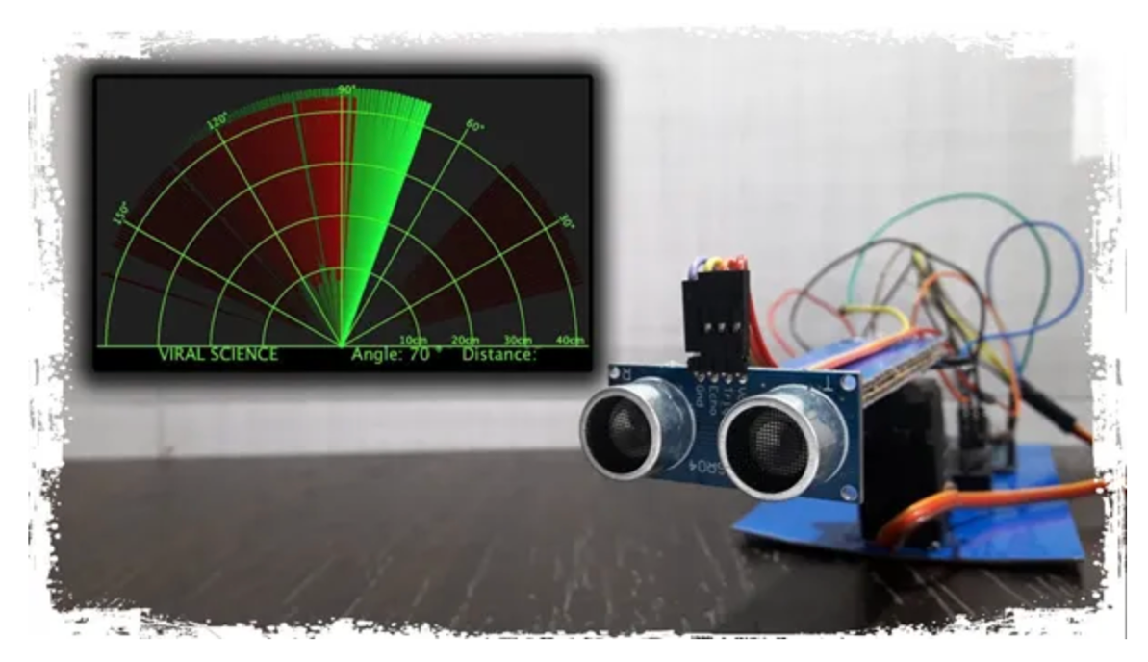
Project Description:

The "Arduino Ultrasonic Radar" is a DIY project that combines an Arduino microcontroller, an ultrasonic sensor, and a servo motor to create a simplified radar-like system capable of detecting objects and displaying their distances in real-time. This project provides an engaging way to learn about sensor integration, servo control, and data visualization with Arduino.

Project Goals:
- Object Detection: The primary goal of this project is to detect objects within a specified range using an ultrasonic sensor.
- Real-time Data Display: The project aims to display real-time distance measurements of detected objects on the Arduino Serial Monitor.
- Simulated Radar Motion: The servo motor mimics the scanning motion of a radar, allowing the ultrasonic sensor to cover a wide area for object detection.

Real Life Applications:

Agriculture:
- Field Monitoring: Ultrasonic sensors can be used to monitor the growth of crops and detect the presence of obstacles, enabling the efficient use of agricultural machinery.
- Livestock Management: These sensors can help monitor the movement and health of livestock, ensuring better management and care.

Marine Applications:
- Depth Measurement: Ultrasonic sensors are used in boats and submarines to measure water depth, aiding in navigation and ensuring safety.
- Fish Finders: These sensors help in detecting fish underwater, assisting fishermen in locating fish schools.

Security Systems:
- Intrusion Detection: Combining radar and ultrasonic sensors can enhance security systems by detecting unauthorized access and movements within a secured area.
- Surveillance: Ultrasonic sensors can be used in surveillance systems to monitor areas for any unusual activity.
Project Benefits:
- Education: This project is an excellent educational tool for learning about Arduino, sensors, and servos.
- Hands-on Experience: It provides hands-on experience with hardware components and coding.
- Customization: You can customize and expand the project by adding more sensors, enhancing the scanning pattern, or incorporating visual displays.
- Fun and Engagement: Building a simplified radar system is a fun and engaging way to explore electronics and programming concepts.

Components:
- Arduino Board (e.g., Arduino Uno)
- Ultrasonic Sensor (e.g., HC-SR04)
- Servo Motor
- Jumper wires
- Power source for the Arduino (e.g., USB connection to a computer)
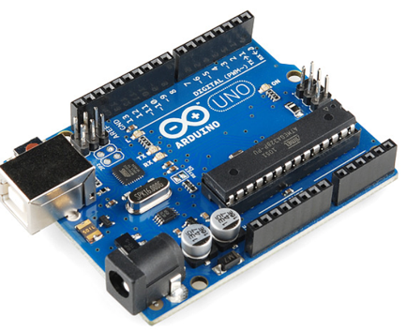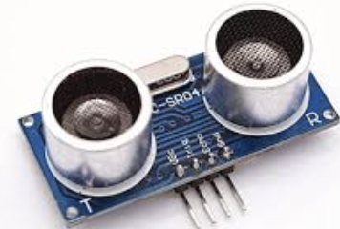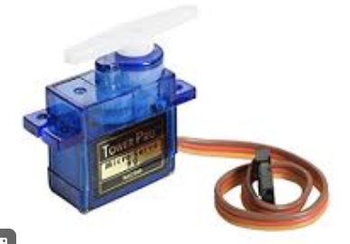

Steps to Create a Simple Radar-Like System:

- Connect the Ultrasonic Sensor:
- Connect the ultrasonic sensor (HC-SR04) to the Arduino as follows:
  - VCC to 5V
  - GND to GND
  - Trig to a digital pin (e.g., D10)
  - Echo to a different digital pin (e.g., D11)

- Connect the Servo Motor:
- Connect the servo motor to the Arduino:
  - Connect the servo's signal wire to a digital pin (e.g., 12) (Yellow)
  - Connect the servo's VCC to 5V (Red)
  - Connect the servo's GND to GND (Brown)
Coding:

Arduino Code:

// Includes the Servo library
#include <Servo.h>.
// Defines Tirg and Echo pins of the Ultrasonic Sensor
const int trigPin = 10;
const int echoPin = 11;
// Variables for the duration and the distance
long duration;
int distance;
Servo myServo; // Creates a servo object for controlling the servo motor
void setup() {
pinMode(trigPin, OUTPUT); // Sets the trigPin as an Output
pinMode(echoPin, INPUT); // Sets the echoPin as an Input
Serial.begin(9600);
myServo.attach(12); // Defines on which pin is the servo motor attached
}
void loop() {
// rotates the servo motor from 15 to 165 degrees
for(int i=15;i<=165;i++){
myServo.write(i);
delay(30);
distance = calculateDistance();// Calls a function for calculating the distance measured by the Ultrasonic sensor for each degree

Serial.print(i); // Sends the current degree into the Serial Port
Serial.print(","); // Sends addition character right next to the previous value needed later in the Processing IDE for indexing
Serial.print(distance); // Sends the distance value into the Serial Port
Serial.print("."); // Sends addition character right next to the previous value needed later in the Processing IDE for indexing
}
// Repeats the previous lines from 165 to 15 degrees
for(int i=165;i>15;i--){
myServo.write(i);
delay(30);
distance = calculateDistance();
Serial.print(i);
Serial.print(",");
Serial.print(distance);
Serial.print(".");
}
}
// Function for calculating the distance measured by the Ultrasonic sensor
int calculateDistance(){

digitalWrite(trigPin, LOW);
delayMicroseconds(2);
// Sets the trigPin on HIGH state for 10 micro seconds
digitalWrite(trigPin, HIGH);
delayMicroseconds(10);
digitalWrite(trigPin, LOW);
duration = pulseIn(echoPin, HIGH); // Reads the echoPin, returns the sound wave travel time in microseconds
distance= duration*0.034/2;
return distance;
}

Processing Code for Visualization(Java):

import processing.serial.*; // imports library for serial communication
import java.awt.event.KeyEvent; // imports library for reading the data from the serial port
import java.io.IOException;
Serial myPort; // defines Object Serial
// defubes variables
String angle="";
String distance="";
String data="";
String noObject;
float pixsDistance;
int iAngle, iDistance;
int index1=0;
int index2=0;
PFont orcFont;
void setup() {

size (1200, 700); // ***CHANGE THIS TO YOUR SCREEN RESOLUTION***
smooth();
myPort = new Serial(this,"/dev/cu.usbmodem142101", 9600); // starts the serial communication
myPort.bufferUntil('.'); // reads the data from the serial port up to the character '.'. So actually it reads this: angle,distance.
}
void draw() {

fill(98,245,31);
// simulating motion blur and slow fade of the moving line
noStroke();
fill(0,4);
rect(0, 0, width, height-height*0.065);

fill(98,245,31); // green color
// calls the functions for drawing the radar
drawRadar();
drawLine();
drawObject();
drawText();
}
void serialEvent (Serial myPort) { // starts reading data from the Serial Port
// reads the data from the Serial Port up to the character '.' and puts it into the String variable "data".
data = myPort.readStringUntil('.');
data = data.substring(0,data.length()-1);

index1 = data.indexOf(","); // find the character ',' and puts it into the variable "index1"
angle= data.substring(0, index1); // read the data from position "0" to position of the variable index1 or thats the value of the angle the Arduino Board sent into the Serial Port
distance= data.substring(index1+1, data.length()); // read the data from position "index1" to the end of the data pr thats the value of the distance

// converts the String variables into Integer
iAngle = int(angle);
iDistance = int(distance);
}
void drawRadar() {
pushMatrix();
translate(width/2,height-height*0.074); // moves the starting coordinats to new location
noFill();
strokeWeight(2);
stroke(98,245,31);
// draws the arc lines
arc(0,0,(width-width*0.0625),(width-width*0.0625),PI,TWO_PI);
arc(0,0,(width-width*0.27),(width-width*0.27),PI,TWO_PI);
arc(0,0,(width-width*0.479),(width-width*0.479),PI,TWO_PI);
arc(0,0,(width-width*0.687),(width-width*0.687),PI,TWO_PI);
// draws the angle lines
line(-width/2,0,width/2,0);
line(0,0,(-width/2)*cos(radians(30)),(-width/2)*sin(radians(30)));
line(0,0,(-width/2)*cos(radians(60)),(-width/2)*sin(radians(60)));
line(0,0,(-width/2)*cos(radians(90)),(-width/2)*sin(radians(90)));
line(0,0,(-width/2)*cos(radians(120)),(-width/2)*sin(radians(120)));
line(0,0,(-width/2)*cos(radians(150)),(-width/2)*sin(radians(150)));
line((-width/2)*cos(radians(30)),0,width/2,0);
popMatrix();
}
void drawObject() {
pushMatrix();
translate(width/2,height-height*0.074); // moves the starting coordinats to new location
strokeWeight(9);
stroke(255,10,10); // red color
pixsDistance = iDistance*((height-height*0.1666)*0.025); // covers the distance from the sensor from cm to pixels
// limiting the range to 40 cms
if(iDistance<40){
// draws the object according to the angle and the distance
line(pixsDistance*cos(radians(iAngle)),-pixsDistance*sin(radians(iAngle)),(width-width*0.505)*cos(radians(iAngle)),-(width-width*0.505)*sin(radians(iAngle)));
}
popMatrix();
}
void drawLine() {
pushMatrix();
strokeWeight(9);
stroke(30,250,60);
translate(width/2,height-height*0.074); // moves the starting coordinats to new location
line(0,0,(height-height*0.12)*cos(radians(iAngle)),-(height-height*0.12)*sin(radians(iAngle))); // draws the line according to the angle
popMatrix();
}
void drawText() { // draws the texts on the screen

pushMatrix();
if(iDistance>40) {
noObject = "Out of Range";
}
else {
noObject = "In Range";
}
fill(0,0,0);
noStroke();
rect(0, height-height*0.0648, width, height);
fill(98,245,31);
textSize(25);

text("10cm",width-width*0.3854,height-height*0.0833);
text("20cm",width-width*0.281,height-height*0.0833);
text("30cm",width-width*0.177,height-height*0.0833);
text("40cm",width-width*0.0729,height-height*0.0833);
textSize(20S);
text("3LOGY TECHCAMP 2024 ", width-width*0.875, height-height*0.0277);
text("Angle: " + iAngle +" °", width-width*0.48, height-height*0.0277);
text("Distance: ", width-width*0.26, height-height*0.0277);
if(iDistance<40) {
text(" " + iDistance +" cm", width-width*0.225, height-height*0.0277);
}
textSize(25);
fill(98,245,60);
translate((width-width*0.4994)+width/2*cos(radians(30)),(height-height*0.0907)-width/2*sin(radians(30)));
rotate(-radians(-60));
text("30°",0,0);
resetMatrix();
translate((width-width*0.503)+width/2*cos(radians(60)),(height-height*0.0888)-width/2*sin(radians(60)));
rotate(-radians(-30));
text("60°",0,0);
resetMatrix();
translate((width-width*0.507)+width/2*cos(radians(90)),(height-height*0.0833)-width/2*sin(radians(90)));
rotate(radians(0));
text("90°",0,0);
resetMatrix();
translate(width-width*0.513+width/2*cos(radians(120)),(height-height*0.07129)-width/2*sin(radians(120)));
rotate(radians(-30));
text("120°",0,0);
resetMatrix();
translate((width-width*0.5104)+width/2*cos(radians(150)),(height-height*0.0574)-width/2*sin(radians(150)));
rotate(radians(-60));
text("150°",0,0);
popMatrix();
}

